

**KP14603 OBJECT ORIENTED PROGRAMMING**

**(SECTION 2)**

**SEMESTER II SESSION 2019/2020**

**ASSIGNMENT II**

**(INDIVIDUAL ASSIGNMENT)**

**LECTURER: MADAM SITI HASNAH TANALOL**

**NAME: TAN XUAN NI**

**MATRIC NUMBER: BI 19110270**

**CONTENTS**

|  |  |  |
| --- | --- | --- |
| **NO.** | **TOPIC** | **PAGE** |
| 1.0 | Introduction | 1-2 |
| 2.0 | Scope/ Proposed Works | 3 |
| 3.0 | Scope/ Proposed Works (Diagram) | 4 |
| 4.0 | Java Code   1. InformationChooseForm.java 2. MyDoctorForm.java 3. MyNurseForm.java | 5  5-7  7-19  19-31 |
| 5.0 | Object Oriented Concept Implementation | 32-33 |
| 6.0 | Read and Write Implementation | 34-35 |
| 7.0 | User Manual (How to use the system) | 36-40 |
| 8.0 | Conclusion | 41 |

**1.0 Introduction**

In 2020, the coronavirus Covid-19 had spread over 200 countries around the world. Covid-19 is a type of virus which is an infectious disease caused by a newly discovered strain of coronavirus. This disease will cause respiratory infections in humans. In our country, the first case of Covid-19 was detected on 24 January 2020 and until now there are over 8000 cases. The increase in cases of Covid-19 patients causes the lack of health and medical support teams. Therefore, Ministry of Health (MoH) had asked for the volunteers who are more anesthesiologists and nurses with specialized experience in intensive care to help the patients. The volunteer who had worked in health care before and they wish to be a volunteer need to fill up the registration form.

The admin and participants will face some problems if they are still using the traditional registration which is paper based. The problems will be faced by the volunteers are that they will easily get a close contact with other people and some of them will not follow the social distancing rules while making a registration at the counter. This will cause the volunteers to be easily get into risk and affected by the Covid-19. They also will waste time standing in the long queues at the counter. Then, they also feel very rushed because they need to take out their free time and make the registration in the business hour due to the fact that they might need to work at that time. Other than that, the admin will also need to spend a lot of time to collect and key in the data of the volunteers. So, the Online Covid-19 2020 Volunteer Registration System is produced.

The main purpose of the Online Covid-19 2020 Volunteer Registration System is to provide volunteers an easier way to make a registration and help admin collect the volunteer’s data systematically. This system also helps to reduce the risk of getting the disease of Covid-19 since the volunteers make the registration online. The volunteers can register online through any Internet-enabled application such as computer and smartphone. The volunteers will done the registration in a few minutes without filling up the paper form and line up to pass up the registration form at the counter. Besides that, this system allows volunteers to choose their field and the state of hospital they would like to join.

The objectives of this system are:

1. Learn to produce an online registration system.
2. To gain knowledge about programming.
3. To reduce the workload and manpower.
4. To provide an online registration form which is always available for the volunteers to take registration.
5. To make it easier and faster for admin and volunteer to manage and make a registration.
6. To obtain the data of the person who is making a registration.
7. To reduce the risk of getting the disease.

**2.0 Scope/ Proposed Works**

1. Volunteer’s field
2. Doctor’s field

* Doctor volunteer registration form

1. Nurse’s field

* Nurse volunteer registration form

1. Doctor volunteer registration form
2. Personal Details

* State of hospital, name, IC number, phone number, birth date, address, e-mail

1. Confirm Registration

* State of hospital, name, IC number, phone number, birth date, address, e-mail

1. Reset Details

* State of hospital, name, IC number, phone number, birth date, address, e-mail

1. Nurse volunteer registration form
2. Personal Details

* State of hospital, name, IC number, phone number, birth date, address, e-mail

1. Confirm Registration

* State of hospital, name, IC number, phone number, birth date, address, e-mail

1. Reset Details

* State of hospital, name, IC number, phone number, birth date, address, e-mail

**3.0 Scope/ Proposed Works**

Nurse volunteer registration form

Doctor volunteer registration form

Nurse’s field

Doctor’s field

Volunteer’s field

Covid-19 2020 Volunteer Registration Form

Nurse volunteer registration form

Doctor volunteer registration form

Confirm Registration

Personal Details

Personal Details

Confirm Registration

1. State of hospital
2. Name
3. IC number
4. Phone number
5. Birth date
6. Address
7. E-mail
8. State of hospital
9. Name
10. IC number
11. Phone number
12. Birth date
13. Address
14. E-mail
15. State of hospital
16. Name
17. IC number
18. Phone number
19. Birth date
20. Address
21. E-mail
22. State of hospital
23. Name
24. IC number
25. Phone number
26. Birth date
27. Address
28. E-mail

Reset Details

Reset Details

1. State of hospital
2. Name
3. IC number
4. Phone number
5. Birth date
6. Address
7. E-mail
8. State of hospital
9. Name
10. IC number
11. Phone number
12. Birth date
13. Address
14. E-mail

**4.0 Java Code**

1. **Volunteer’s field class file (InformationChooseForm.java)**

// OOP Java Individual Assignment 2 (BI 1911270 TAN XUAN NI)  
// COVID-19 2020 Volunteer Registration Form  
  
//Let the user choose and click on the button that the field of volunteer they want to join   
  
// Import statements  
import javax.swing.*;   
import java.awt.*;   
import java.awt.event.*;   
import java.io.*;  
  
// Begin the InformationChooseForm class   
class InformationChooseForm extends JFrame  
{   
 // Create component classes  
 private JLabel label, label1;  
 private JPanel panel;  
 private JButton doctor, nurse;  
 private ImageIcon icon, icon1;  
   
 // Begin the InformationChooseForm constructor  
 public InformationChooseForm()  
 {   
 // Create a new JFrame Container  
 // Specify the size and the location of the frame  
 // Let the frame resizeable  
 JFrame frame = new JFrame("COVID-19 VOLUNTEER Registration(Choose Field)");   
 frame.setBounds(550, 250, 500, 300);   
 frame.setResizable(true);   
  
 // Terminate the program when the user closes the application  
 frame.setDefaultCloseOperation(JFrame.EXIT_ON_CLOSE);   
   
 // Create a new JPanel  
 // Set the layout of the panel  
 // Add it to the frame  
 panel = new JPanel();   
 panel.setLayout(null);  
 frame.add(panel);   
   
 // Create a new label  
 // Set the font, size, and location of label  
 // Add it to the panel   
 label = new JLabel("COVID-19 2020 VOLUNTEER ONLINE REGISTRATION");   
 label.setFont(new Font("Arial", Font.BOLD, 15));   
 label.setSize(500, 20);   
 label.setLocation(50, 50);  
 panel.add(label);   
  
 // Create a label1  
 // Set the font, size, and location of label1  
 // Add it to the panel   
 label1 = new JLabel("Please choose the field of volunteer you want to be.\n Thank You !");  
 label1.setFont(new Font("Arial", Font.BOLD, 13));  
 label1.setSize(500, 20);  
 label1.setLocation(40, 80);  
 panel.add(label1);  
   
 // Create an new icon for the buttons  
 // Resize the icon  
 icon = new ImageIcon("doctor.png");  
 Image newicon = icon.getImage();  
 Image modifynewicon = newicon.getScaledInstance(30, 30, java.awt.Image.SCALE_SMOOTH);  
 icon = new ImageIcon(modifynewicon);  
   
 icon1 = new ImageIcon("nurse.png");  
 Image newicon1 = icon1.getImage();  
 Image modifynewicon1 = newicon1.getScaledInstance(30, 30, java.awt.Image.SCALE_SMOOTH);  
 icon1 = new ImageIcon(modifynewicon1);  
  
 // Create an icon and a doctor button to let the user press the field they want to join  
 // Set the font, size and location of the button  
 // Add action listener  
 doctor = new JButton("Doctor", icon);  
 doctor.setSize(150, 50);  
 doctor.setLocation(80, 130);  
 doctor.addActionListener(new ActionListener() //Anonymous Inner class   
 { public void actionPerformed(ActionEvent e)  
 {   
 // After press the Doctor button, it will move to MyDoctorForm class   
 new MyDoctorForm();  
 }  
   
 });  
 // Add it to the panel  
 panel.add(doctor);   
   
 // Create an icon and a nurse button to let the user press the field they want to join  
 // Set the font, size and location of the button  
 // Add action listener   
 nurse = new JButton("Nurse", icon1);  
 nurse.setSize(150, 50);   
 nurse.setLocation(260, 130);  
 nurse.addActionListener(new ActionListener() //Anonymous Inner class  
 { public void actionPerformed(ActionEvent e)  
 {   
 // After press the Nurse button, it will move to MyNurseForm class   
 new MyNurseForm();  
 }  
   
 });  
 // Add it to the panel  
 panel.add(nurse);  
  
 // Display the frame  
 frame.setVisible(true);  
 }  
}   
   
// Driver class  
class Choose   
{   
 public static void main(String[] args) throws Exception   
 {   
 InformationChooseForm chooseform = new InformationChooseForm();   
 }   
}

1. **Doctor volunteer registration form class file (MyDoctorForm.java)**

// OOP Java Individual Assignment 2 (BI 1911270 TAN XUAN NI)  
// COVID-19 2020 Volunteer Registration Form   
  
// Let the user fill the COVID-19 2020 Volunteer Registration Form (Doctor)  
  
// Import statements  
import javax.swing.*;   
import java.awt.*;   
import java.awt.event.*;   
import java.io.*;  
  
// Begin the MyDoctorForm class   
class MyDoctorForm extends JFrame implements ActionListener {   
   
 //Create component classes  
 private JLabel title, title1, state, name, ic, phone, gender, birth, address, email, remind, remind1;   
 private JTextField myname, myic, myphone, myaddress, myaddress1, myaddress2, myemail;   
 private JRadioButton male, female;   
 private ButtonGroup mybutton;   
 private JComboBox choosenstate, day, month, year;   
 private JCheckBox term;   
 private JButton register, reset;   
 private JTextArea mybox;   
 private ImageIcon icon, icon1, icon2, icon3, icon4, icon5, icon6, icon7;  
 FileWriter writer;  
   
 private String states[] // Create an array of state of hospital  
 = { "Kedah", "Perlis", "Pulau Pinang", "Perak", "Kelantan", "Terengganu", "Selangor",   
 "Negeri Sembilan", "Melaka", "Pahang", "Johor", "Sabah", "Sarawak"};   
   
 private String days[] // Create an array of days  
 = { "1", "2", "3", "4", "5", "6", "7", "8", "9", "10",   
 "11", "12", "13", "14", "15", "16", "17", "18", "19", "20",   
 "21", "22", "23", "24", "25", "26", "27", "28", "29", "30",   
 "31" };   
   
 private String months[] // Create an array of months  
 = { "JAN", "FEB", "MAR", "APR", "MAY", "JUN", "JULY", "AUG", "SEPT", "OCT", "NOV", "DEC" };   
   
 private String years[] // Create an array of years  
 = { "1960", "1961", "1962", "1963", "1964", "1965", "1966", "1967", "1968","1969",  
 "1970", "1971", "1972", "1973", "1974", "1975", "1976", "1977", "1978","1979",  
 "1980", "181", "1982", "1983", "1984", "1985", "1986", "1987", "1988","1989",  
 "1990", "1991", "1992", "1993", "1994", "1995", "1996", "1997", "1998", "1999"};   
   
 // Begin the MyDoctorForm constructor   
 public MyDoctorForm()   
 {   
 // Create a new JFrame Container  
 // Specify the size and the location of the frame   
 // Set to enable the user resizing the frame  
 JFrame frame = new JFrame("Covid-19 2020 Volunteer Registration Form");   
 frame.setBounds(280, 100, 1000, 650);   
 frame.setResizable(true);  
   
 //Terminate the program when the user closes the application  
 frame.setDefaultCloseOperation(EXIT_ON_CLOSE);  
   
 // Create a new JPanel  
 // Set the background colour and the layout of the panel  
 // Add it to the frame  
 JPanel panel = new JPanel();   
 panel.setBackground(Color.WHITE);   
 panel.setLayout(null);  
 frame.add(panel);  
   
 // Create an new icon for dialogs, title and labels  
 // Resize the icon  
 icon = new ImageIcon("care.png");   
 Image newicon = icon.getImage();   
 Image modifynewicon = newicon.getScaledInstance(50, 50, java.awt.Image.SCALE_SMOOTH);  
 icon = new ImageIcon(modifynewicon);  
   
 icon1 = new ImageIcon("register.png");   
 Image newicon1 = icon1.getImage();   
 Image modifynewicon1 = newicon1.getScaledInstance(15, 15, java.awt.Image.SCALE_SMOOTH);  
 icon1 = new ImageIcon(modifynewicon1);  
   
 icon2 = new ImageIcon("reset.png");   
 Image newicon2 = icon2.getImage();   
 Image modifynewicon2 = newicon2.getScaledInstance(15, 15, java.awt.Image.SCALE_SMOOTH);  
 icon2 = new ImageIcon(modifynewicon2);  
   
 icon3 = new ImageIcon("health.png");   
 Image newicon3 = icon3.getImage();   
 Image modifynewicon3 = newicon3.getScaledInstance(70, 45, java.awt.Image.SCALE_SMOOTH);  
 icon3 = new ImageIcon(modifynewicon3);  
   
 icon4 = new ImageIcon("tick.png");   
 Image newicon4 = icon4.getImage();   
 Image modifynewicon4 = newicon4.getScaledInstance(15, 15, java.awt.Image.SCALE_SMOOTH);  
 icon4 = new ImageIcon(modifynewicon4);  
   
 icon5 = new ImageIcon("like.png");   
 Image newicon5 = icon5.getImage();   
 Image modifynewicon5 = newicon5.getScaledInstance(50, 50, java.awt.Image.SCALE_SMOOTH);  
 icon5 = new ImageIcon(modifynewicon5);  
   
 icon6 = new ImageIcon("copy.png");   
 Image newicon6 = icon6.getImage();   
 Image modifynewicon6 = newicon6.getScaledInstance(50, 50, java.awt.Image.SCALE_SMOOTH);  
 icon6 = new ImageIcon(modifynewicon6);  
   
 icon7 = new ImageIcon("alert.png");   
 Image newicon7 = icon7.getImage();   
 Image modifynewicon7 = newicon7.getScaledInstance(50, 50, java.awt.Image.SCALE_SMOOTH);  
 icon7 = new ImageIcon(modifynewicon7);  
   
   
 // Create an icon and a label for title  
 // Set the font, size, and location of title label  
 // Add it to the panel   
 title = new JLabel("Covid-19 2020 Volunteer Registration Form", icon3, SwingConstants.CENTER);   
 title.setFont(new Font("Britannic Bold", Font.BOLD, 25));   
 title.setSize(800, 50);   
 title.setLocation(100, 25);   
 panel.add(title);   
   
 // Create an icon and a label for title1  
 // Set the font, size, and location of title1 label  
 // Add it to the panel  
 title1 = new JLabel("(Doctor)");   
 title1.setFont(new Font("Britannic Bold", Font.BOLD, 20));   
 title1.setSize(500, 40);   
 title1.setLocation(480, 65);   
 panel.add(title1);   
   
   
 // Create an icon and a label for the state question  
 // Set the font, size, and location of state label  
 // Add it to the panel  
 state = new JLabel("Volunteer in which state of hospital?", icon4, SwingConstants.LEFT);   
 state.setFont(new Font("Britannic Bold", Font.PLAIN, 15));   
 state.setSize(350, 20);   
 state.setLocation(70, 110);   
 panel.add(state);   
   
 // Create a JComboBox of choosenstate to let the user selects the state of hospital thet want from the list given  
 // Set the font, size and location of the combo box  
 // Add it to the panel  
 choosenstate = new JComboBox(states);   
 choosenstate.setFont(new Font("Tahoma", Font.PLAIN, 15));   
 choosenstate.setSize(220, 20);   
 choosenstate.setLocation(90, 135);   
 panel.add(choosenstate);   
   
 // Create an icon and a label for name  
 // Set the font, size, and location of name label  
 // Add it to the panel   
 name = new JLabel("Name", icon4, SwingConstants.LEFT);   
 name.setFont(new Font("Britannic Bold", Font.PLAIN, 15));   
 name.setSize(150, 20);   
 name.setLocation(70, 180);   
 panel.add(name);   
   
 // Create a myname text field to enable the user to enter the text  
 // Set the font, size and location of myname text field  
 // Add it to the panel  
 myname = new JTextField();   
 myname.setFont(new Font("Tahoma", Font.PLAIN, 15));   
 myname.setSize(200, 20);   
 myname.setLocation(250, 180);   
 panel.add(myname);   
   
 // Create an icon and a label for ic  
 // Set the font, size, and location of ic label  
 // Add it to the panel  
 ic = new JLabel("IC Number", icon4, SwingConstants.LEFT);   
 ic.setFont(new Font("Britannic Bold", Font.PLAIN, 15));   
 ic.setSize(200, 20);   
 ic.setLocation(70, 220);   
 panel.add(ic);   
   
 // Create a myic text field to enable the user to enter the text  
 // Set the font, size and location of myic text field  
 // Add it to the panel  
 myic = new JTextField();  
 myic.setFont(new Font("Tahoma", Font.PLAIN, 15));   
 myic.setSize(200, 20);   
 myic.setLocation(250, 220);   
 panel.add( myic);   
   
 // Create an icon and a label for phone  
 // Set the font, size, and location of phone label  
 // Add it to the panel  
 phone = new JLabel("Phone Number", icon4, SwingConstants.LEFT);   
 phone.setFont(new Font("Britannic Bold", Font.PLAIN, 15));   
 phone.setSize(200, 20);   
 phone.setLocation(70, 260);   
 panel.add(phone);  
   
 // Create a myphone text field to enable the user to enter the text  
 // Set the font, size and location of myphone text field  
 // Add it to the panel  
 myphone = new JTextField();   
 myphone.setFont(new Font("Tahoma", Font.PLAIN, 15));   
 myphone.setSize(200, 20);   
 myphone.setLocation(250, 260);   
 panel.add(myphone);   
   
 // Create an icon and a label for gender  
 // Set the font, size, and location of gender label  
 // Add it to the panel  
 gender = new JLabel("Gender", icon4, SwingConstants.LEFT);   
 gender.setFont(new Font("Britannic Bold", Font.PLAIN, 15));   
 gender.setSize(100, 20);   
 gender.setLocation(70, 300);   
 panel.add(gender);   
   
 // Create male and female radio button to let the user select only one button at any one time  
 // Set the font, size, and location of each button  
 // Add them to the panel  
 male = new JRadioButton("Male");   
 male.setFont(new Font("Tahoma", Font.PLAIN, 15));   
 male.setSelected(true);   
 male.setSize(75, 20);   
 male.setLocation(250, 300);   
 panel.add(male);   
   
 female = new JRadioButton("Female");   
 female.setFont(new Font("Tahoma", Font.PLAIN, 15));   
 female.setSelected(false);   
 female.setSize(80, 20);   
 female.setLocation(325, 300);   
 panel.add(female);   
   
 // Define a button group  
 // Add the male and female radio button to a button group  
 mybutton = new ButtonGroup();   
 mybutton.add(male);   
 mybutton.add(female);   
   
   
 // Create an icon and a label of birth date  
 // Set the font, size, and location of birth date label  
 // Add it to the panel  
 birth = new JLabel("Birth date", icon4, SwingConstants.LEFT);   
 birth.setFont(new Font("Britannic Bold", Font.PLAIN, 15));   
 birth.setSize(100, 20);   
 birth.setLocation(70, 340);   
 panel.add(birth);   
   
   
 // Create a JComboBox of day, month and year to let the user selects their own birth date from the list given  
 // Set the font, size and location of every combo box  
 // Add them to the panel   
 day = new JComboBox(days);   
 day.setFont(new Font("Tahoma", Font.PLAIN, 15));   
 day.setSize(50, 20);   
 day.setLocation(250, 340);   
 panel.add(day);   
   
 month = new JComboBox(months);   
 month.setFont(new Font("Tahoma", Font.PLAIN, 15));   
 month.setSize(60, 20);   
 month.setLocation(320, 340);   
 panel.add(month);   
   
 year = new JComboBox(years);   
 year.setFont(new Font("Tahoma", Font.PLAIN, 15));   
 year.setSize(60, 20);   
 year.setLocation(390, 340);   
 panel.add(year);   
   
 // Create an icon and a label for address  
 // Set the font, size and location of adrress label   
 // Add it to the panel  
 address = new JLabel("Address", icon4, SwingConstants.LEFT);   
 address.setFont(new Font("Britannic Bold", Font.PLAIN, 15));   
 address.setSize(100, 20);   
 address.setLocation(70, 380);   
 panel.add(address);   
   
 // Create a few address text field to enable the user to enter the text  
 // Set the font, size and location of every address text field  
 // Add them to the panel   
 myaddress = new JTextField();   
 myaddress.setFont(new Font("Tahoma", Font.PLAIN, 15));   
 myaddress.setSize(200, 20);   
 myaddress.setLocation(250, 380);   
 panel.add(myaddress);   
   
 myaddress1 = new JTextField();   
 myaddress1.setFont(new Font("Tahoma", Font.PLAIN, 15));   
 myaddress1.setSize(200, 20);   
 myaddress1.setLocation(250, 410);   
 panel.add(myaddress1);  
   
 myaddress2 = new JTextField();   
 myaddress2.setFont(new Font("Tahoma", Font.PLAIN, 15));   
 myaddress2.setSize(200, 20);   
 myaddress2.setLocation(250, 440);   
 panel.add(myaddress2);  
   
 // Create an icon and a label for email  
 // Set the font, size and location of email label   
 // Add it to the panel  
 email = new JLabel("E-mail", icon4, SwingConstants.LEFT);   
 email.setFont(new Font("Britannic Bold", Font.PLAIN, 15));   
 email.setSize(150, 20);   
 email.setLocation(70, 480);   
 panel.add(email);   
   
 // Create a myemail text field to enable the user to enter a line of text  
 // Set the font, size and location of myemail text field   
 // Add it to the panel  
 myemail = new JTextField();   
 myemail.setFont(new Font("Tahoma", Font.PLAIN, 15));   
 myemail.setSize(200, 20);   
 myemail.setLocation(250, 480);   
 panel.add(myemail);   
   
 // Create the check box to enable the user selects or deselects the check box  
 // Set the font, size and location of term check box   
 // Add it to the panel  
 term = new JCheckBox("Please Agree to the Terms And Conditions.");   
 term.setFont(new Font("Arial", Font.PLAIN, 15));   
 term.setSize(320, 20);   
 term.setLocation(120, 525);   
 panel.add(term);   
   
   
 // Create an icon and a register button to let the user press after finish filing the registration from  
 // Set the font, size and location of the button  
 // Add action listener  
 // Add it to the panel   
 register = new JButton("REGISTER", icon1);   
 register.setFont(new Font("Arial", Font.BOLD, 12));   
 register.setSize(140, 20);   
 register.setLocation(100, 570);   
 register.addActionListener(this);   
 panel.add(register);   
   
 // Create an icon and a reset button to let the user press after finish filing the registration from  
 // Set the font, size and location of the button  
 // Add action listener  
 // Add it to the panel  
 reset = new JButton("RESET", icon2);   
 reset.setFont(new Font("Arial", Font.BOLD, 12));   
 reset.setSize(140, 20);   
 reset.setLocation(300, 570);   
 reset.addActionListener(this);   
 panel.add(reset);   
   
 // Create a label for remind and remind1  
 // Set the font, size, and location of remind and remind1 label   
 // Add them to the panel  
 remind = new JLabel("Please check your personal details."); // Create a label  
 remind.setFont(new Font("Tahoma", Font.BOLD, 12));   
 remind.setSize(400, 20);   
 remind.setLocation(550, 120);   
 panel.add(remind);   
   
 remind1 = new JLabel("Please press RESET button, if your details is wrong.");   
 remind1.setFont(new Font("Tahoma", Font.BOLD, 12));   
 remind1.setSize(400, 20);   
 remind1.setLocation(550, 140);   
 panel.add(remind1);   
  
 // Create a text area of mybox to show the output of the registration form  
 // Set the font, size, and location of mybox text area  
 // Set the mybox text area can wrap the lines of the JTextArea if it does not fit in the JTextArea   
 // Set the mybox text area cannot be edited  
 // Add it to the panel  
 mybox = new JTextArea();   
 mybox.setFont(new Font("Tahoma", Font.PLAIN, 15));   
 mybox.setBackground(Color.PINK);   
 mybox.setSize(380, 400);   
 mybox.setLocation(550, 170);   
 mybox.setLineWrap(true);   
 mybox.setEditable(false);   
 panel.add(mybox);   
   
 // Display the frame   
 frame.setVisible(true);   
   
 // Create an icon and a dialog that show a message  
 JOptionPane.showMessageDialog(null, " Dear Doctor,\n Thank You for Willingness to Volunteer Your Time and Skills !\n Please Fill in the Registration Form ", "Message", JOptionPane.INFORMATION_MESSAGE, icon);  
  
 }   
   
 // Handle the button event  
 // Method actionPerformed()   
 // To get the action performed by the user and act accordingly   
 public void actionPerformed(ActionEvent e)   
 {   
   
 if (e.getSource() == register)   
 {   
 if (term.isSelected())   
 {   
 // If the user press REGISTER button and select the check box after filling the form   
 // The registration output will print out on the mybox text area  
 String data = "Covid-19 2020 Volunteer Registration Form\nPersonal Detail (Doctor)\n\n";  
 String data1 = "Volunteer in which state of hospital?\n" + (String)choosenstate.getSelectedItem() + "\n\n";  
 String data2 = "Name : " + myname.getText() + "\n";  
 String data3 ="IC Number: " + myic.getText() + "\n";  
 String data4 = "Phone Number : " + myphone.getText() + "\n";   
 String data5;   
 if (male.isSelected())   
 data5 = "Gender : Male" + "\n";   
 else  
 data5 = "Gender : Female" + "\n";   
   
 String data6 = "Birth Date : " + (String)day.getSelectedItem() + " "+ (String)month.getSelectedItem()   
 + " " + (String)year.getSelectedItem() + "\n";   
   
 String data7 = "Address : " + myaddress.getText() + ", \n " + myaddress1.getText() + ", \n "   
 + myaddress2.getText() + "\n" ;   
 String data8 = "E-mail : " + myemail.getText() + "\n";   
   
 mybox.setText(data + data1 + data2 + data3 + data4 + data5 + data6 + data7 + data8);   
 mybox.setEditable(false);  
   
 // Create an icon and a dialog that show a message  
 JOptionPane.showMessageDialog(null, "Dear Doctor,\nYour registration is CONFIRM !", "Message", JOptionPane.INFORMATION_MESSAGE, icon5);  
   
 // Create a text file for enable to read the input from external storage file   
 // and write the output to external file  
 try  
 { writer = new FileWriter("Covid-19 Volunteer-Doctor.txt", true);  
 writer.write("Covid-19 2020 Volunteer Registration Form Personal Detail(Doctor)");  
 writer.write(System.getProperty("line.separator"));  
 writer.write(System.getProperty("line.separator"));  
   
 writer.write(state.getText() + "\t" +(String)choosenstate.getSelectedItem());  
 writer.write(System.getProperty("line.separator"));  
   
 writer.write(name.getText() + ": \t\t" + myname.getText());  
 writer.write(System.getProperty("line.separator"));  
   
 writer.write(ic.getText() + ": \t" + myic.getText());  
 writer.write(System.getProperty("line.separator"));  
   
 writer.write(phone.getText() + ": \t" + myphone.getText());  
 writer.write(System.getProperty("line.separator"));  
   
 if (male.isSelected())   
 writer.write(gender.getText() + ": \t\t" + "Male");  
 else  
 writer.write(gender.getText() + ": \t\t" + "Female");  
 writer.write(System.getProperty("line.separator"));  
   
 writer.write(birth.getText() + ": \t" + (String)day.getSelectedItem() + " "+ (String)month.getSelectedItem()   
 + " " + (String)year.getSelectedItem());  
 writer.write(System.getProperty("line.separator"));  
   
 writer.write(address.getText() + ": \t" + myaddress.getText() + ", \n\t " + myaddress1.getText()   
 + ", \n\t " + myaddress2.getText());  
 writer.write(System.getProperty("line.separator"));  
   
 writer.write(email.getText() + ": \t" + myemail.getText());  
 writer.write(System.getProperty("line.separator"));  
   
 writer.close();  
   
 // Create an icon and a dialog that show a message  
 JOptionPane.showMessageDialog(null, "File Written Had Stored", "Message", JOptionPane.INFORMATION_MESSAGE, icon6);  
 }   
 catch(Exception ae)  
 { JOptionPane.showMessageDialog(null, "Error");  
 }  
 }   
 else   
 // The dialog message will pop up to remind the user select the check box  
 {   
 mybox.setText("");   
   
 JOptionPane.showMessageDialog(null, "Please accept the terms & conditions.", "Message", JOptionPane.INFORMATION_MESSAGE, icon7);  
 }   
 }   
   
 // If the user press RESET button, all the information will be clear  
 else if (e.getSource() == reset)   
 {   
 String def = "";  
 choosenstate.setSelectedIndex(0);   
 myname.setText(def);   
 myic.setText(def);  
 myphone.setText(def);   
 day.setSelectedIndex(0);   
 month.setSelectedIndex(0);   
 year.setSelectedIndex(0);   
 myaddress.setText(def);  
 myaddress1.setText(def);  
 myaddress2.setText(def);  
 myemail.setText(def);   
   
 mybox.setText(def);   
 term.setSelected(false);   
   
 }   
   
 }   
}   
   
// Driver class   
class RegistrationDoctor   
{   
 public static void main(String[] args) throws Exception   
 {   
 MyDoctorForm thisform = new MyDoctorForm();   
 }   
}

1. **Nurse volunteer registration form class file (MyNurseForm.java)**

// OOP Java Individual Assignment 2 (BI 1911270 TAN XUAN NI)  
// COVID-19 2020 Volunteer Registration Form   
  
// Let the user fill the COVID-19 2020 Volunteer Registration Form (Nurse)  
  
// Import statements  
import javax.swing.*;   
import java.awt.*;   
import java.awt.event.*;   
import java.io.*;  
  
// Begin the MyDoctorForm class   
class MyNurseForm extends JFrame implements ActionListener {   
   
 //Create component classes  
 private JLabel title, title1, state, name, ic, phone, gender, birth, address, email, remind, remind1;   
 private JTextField myname, myic, myphone, myaddress, myaddress1, myaddress2, myemail;   
 private JRadioButton male, female;   
 private ButtonGroup mybutton;   
 private JComboBox choosenstate, day, month, year;   
 private JCheckBox term;   
 private JButton register, reset;   
 private JTextArea mybox;   
 private ImageIcon icon, icon1, icon2, icon3, icon4, icon5, icon6, icon7;  
 FileWriter writer;  
   
 private String states[] // Create an array of state of hospital  
 = { "Kedah", "Perlis", "Pulau Pinang", "Perak", "Kelantan", "Terengganu", "Selangor",   
 "Negeri Sembilan", "Melaka", "Pahang", "Johor", "Sabah", "Sarawak"};   
   
 private String days[] // Create an array of days  
 = { "1", "2", "3", "4", "5", "6", "7", "8", "9", "10",   
 "11", "12", "13", "14", "15", "16", "17", "18", "19", "20",   
 "21", "22", "23", "24", "25", "26", "27", "28", "29", "30",   
 "31" };   
   
 private String months[] // Create an array of months  
 = { "JAN", "FEB", "MAR", "APR", "MAY", "JUN", "JULY", "AUG", "SEPT", "OCT", "NOV", "DEC" };   
   
 private String years[] // Create an array of years  
 = { "1960", "1961", "1962", "1963", "1964", "1965", "1966", "1967", "1968","1969",  
 "1970", "1971", "1972", "1973", "1974", "1975", "1976", "1977", "1978","1979",  
 "1980", "181", "1982", "1983", "1984", "1985", "1986", "1987", "1988","1989",  
 "1990", "1991", "1992", "1993", "1994", "1995", "1996", "1997", "1998", "1999"};   
   
 // Begin the MyDoctorForm constructor   
 public MyNurseForm()   
 {   
 // Create a new JFrame Container  
 // Set the position and size of the frame   
 // Set to enable the user resizing the frame  
 JFrame frame = new JFrame("Covid-19 2020 Volunteer Registration Form");   
 frame.setBounds(280, 100, 1000, 650);   
 frame.setResizable(true);  
   
 //Terminate the program when the user closes the application  
 frame.setDefaultCloseOperation(EXIT_ON_CLOSE);  
   
 // Create a new JPanel  
 // Set the background colour and the layout of the panel  
 // Add it to the frame  
 JPanel panel = new JPanel();   
 panel.setBackground(Color.WHITE);   
 panel.setLayout(null);  
 frame.add(panel);  
   
 // Create an new icon for dialogs, title and labels  
 // Resize the icon  
 icon = new ImageIcon("care.png");   
 Image newicon = icon.getImage();   
 Image modifynewicon = newicon.getScaledInstance(50, 50, java.awt.Image.SCALE_SMOOTH);  
 icon = new ImageIcon(modifynewicon);  
   
 icon1 = new ImageIcon("register.png");   
 Image newicon1 = icon1.getImage();   
 Image modifynewicon1 = newicon1.getScaledInstance(15, 15, java.awt.Image.SCALE_SMOOTH);  
 icon1 = new ImageIcon(modifynewicon1);  
   
 icon2 = new ImageIcon("reset.png");   
 Image newicon2 = icon2.getImage();   
 Image modifynewicon2 = newicon2.getScaledInstance(15, 15, java.awt.Image.SCALE_SMOOTH);  
 icon2 = new ImageIcon(modifynewicon2);  
   
 icon3 = new ImageIcon("health.png");   
 Image newicon3 = icon3.getImage();   
 Image modifynewicon3 = newicon3.getScaledInstance(70, 45, java.awt.Image.SCALE_SMOOTH);  
 icon3 = new ImageIcon(modifynewicon3);  
   
 icon4 = new ImageIcon("tick.png");   
 Image newicon4 = icon4.getImage();   
 Image modifynewicon4 = newicon4.getScaledInstance(15, 15, java.awt.Image.SCALE_SMOOTH);  
 icon4 = new ImageIcon(modifynewicon4);  
   
 icon5 = new ImageIcon("like.png");   
 Image newicon5 = icon5.getImage();   
 Image modifynewicon5 = newicon5.getScaledInstance(50, 50, java.awt.Image.SCALE_SMOOTH);  
 icon5 = new ImageIcon(modifynewicon5);  
   
 icon6 = new ImageIcon("copy.png");   
 Image newicon6 = icon6.getImage();   
 Image modifynewicon6 = newicon6.getScaledInstance(50, 50, java.awt.Image.SCALE_SMOOTH);  
 icon6 = new ImageIcon(modifynewicon6);  
   
 icon7 = new ImageIcon("alert.png");   
 Image newicon7 = icon7.getImage();   
 Image modifynewicon7 = newicon7.getScaledInstance(50, 50, java.awt.Image.SCALE_SMOOTH);  
 icon7 = new ImageIcon(modifynewicon7);  
   
 // Create an icon and a label for title  
 // Set the font, size, and location of title label  
 // Add it to the panel   
 title = new JLabel("Covid-19 2020 Volunteer Registration Form", icon3, SwingConstants.CENTER);   
 title.setFont(new Font("Britannic Bold", Font.BOLD, 25));   
 title.setSize(800, 50);   
 title.setLocation(100, 25);   
 panel.add(title);   
   
 // Create an icon and a label for title1  
 // Set the font, size, and location of title1 label  
 // Add it to the panel  
 title1 = new JLabel("(Nurse)");   
 title1.setFont(new Font("Britannic Bold", Font.BOLD, 20));   
 title1.setSize(500, 40);   
 title1.setLocation(480, 65);   
 panel.add(title1);   
   
   
 // Create an icon and a label for the state question  
 // Set the font, size, and location of state label  
 // Add it to the panel  
 state = new JLabel("Volunteer in which state of hospital?", icon4, SwingConstants.LEFT);   
 state.setFont(new Font("Britannic Bold", Font.PLAIN, 15));   
 state.setSize(350, 20);   
 state.setLocation(70, 110);   
 panel.add(state);   
   
 // Create a JComboBox of choosenstate to let the user selects the state of hospital thet want from the list given  
 // Set the font, size and location of the combo box  
 // Add it to the panel  
 choosenstate = new JComboBox(states);   
 choosenstate.setFont(new Font("Tahoma", Font.PLAIN, 15));   
 choosenstate.setSize(220, 20);   
 choosenstate.setLocation(90, 135);   
 panel.add(choosenstate);   
   
 // Create an icon and a label for name  
 // Set the font, size, and location of name label  
 // Add it to the panel   
 name = new JLabel("Name", icon4, SwingConstants.LEFT);   
 name.setFont(new Font("Britannic Bold", Font.PLAIN, 15));   
 name.setSize(150, 20);   
 name.setLocation(70, 180);   
 panel.add(name);   
   
 // Create a myname text field to enable the user to enter the text  
 // Set the font, size and location of myname text field  
 // Add it to the panel  
 myname = new JTextField();   
 myname.setFont(new Font("Tahoma", Font.PLAIN, 15));   
 myname.setSize(200, 20);   
 myname.setLocation(250, 180);   
 panel.add(myname);   
   
 // Create an icon and a label for ic  
 // Set the font, size, and location of ic label  
 // Add it to the panel  
 ic = new JLabel("IC Number", icon4, SwingConstants.LEFT);   
 ic.setFont(new Font("Britannic Bold", Font.PLAIN, 15));   
 ic.setSize(200, 20);   
 ic.setLocation(70, 220);   
 panel.add(ic);   
   
 // Create a myic text field to enable the user to enter the text  
 // Set the font, size and location of myic text field  
 // Add it to the panel  
 myic = new JTextField();  
 myic.setFont(new Font("Tahoma", Font.PLAIN, 15));   
 myic.setSize(200, 20);   
 myic.setLocation(250, 220);   
 panel.add( myic);   
   
 // Create an icon and a label for phone  
 // Set the font, size, and location of phone label  
 // Add it to the panel  
 phone = new JLabel("Phone Number", icon4, SwingConstants.LEFT);   
 phone.setFont(new Font("Britannic Bold", Font.PLAIN, 15));   
 phone.setSize(200, 20);   
 phone.setLocation(70, 260);   
 panel.add(phone);  
   
 // Create a myphone text field to enable the user to enter the text  
 // Set the font, size and location of myphone text field  
 // Add it to the panel  
 myphone = new JTextField();   
 myphone.setFont(new Font("Tahoma", Font.PLAIN, 15));   
 myphone.setSize(200, 20);   
 myphone.setLocation(250, 260);   
 panel.add(myphone);   
   
 // Create an icon and a label for gender  
 // Set the font, size, and location of gender label  
 // Add it to the panel  
 gender = new JLabel("Gender", icon4, SwingConstants.LEFT);   
 gender.setFont(new Font("Britannic Bold", Font.PLAIN, 15));   
 gender.setSize(100, 20);   
 gender.setLocation(70, 300);   
 panel.add(gender);   
   
 // Create male and female radio button to let the user select only one button at any one time  
 // Set the font, size, and location of each button  
 // Add them to the panel  
 male = new JRadioButton("Male");   
 male.setFont(new Font("Tahoma", Font.PLAIN, 15));   
 male.setSelected(true);   
 male.setSize(75, 20);   
 male.setLocation(250, 300);   
 panel.add(male);   
   
 female = new JRadioButton("Female");   
 female.setFont(new Font("Tahoma", Font.PLAIN, 15));   
 female.setSelected(false);   
 female.setSize(80, 20);   
 female.setLocation(325, 300);   
 panel.add(female);   
   
 // Define a button group  
 // Add the male and female radio button to a button group  
 mybutton = new ButtonGroup();   
 mybutton.add(male);   
 mybutton.add(female);   
   
 // Create an icon and a label of birth date  
 // Set the font, size, and location of birth date label  
 // Add it to the panel  
 birth = new JLabel("Birth date", icon4, SwingConstants.LEFT);   
 birth.setFont(new Font("Britannic Bold", Font.PLAIN, 15));   
 birth.setSize(100, 20);   
 birth.setLocation(70, 340);   
 panel.add(birth);   
   
 // Create a JComboBox of day, month and year to let the user selects their own birth date from the list given  
 // Set the font, size and location of every combo box  
 // Add them to the panel   
 day = new JComboBox(days);   
 day.setFont(new Font("Tahoma", Font.PLAIN, 15));   
 day.setSize(50, 20);   
 day.setLocation(250, 340);   
 panel.add(day);   
   
 month = new JComboBox(months);   
 month.setFont(new Font("Tahoma", Font.PLAIN, 15));   
 month.setSize(60, 20);   
 month.setLocation(320, 340);   
 panel.add(month);   
   
 year = new JComboBox(years);   
 year.setFont(new Font("Tahoma", Font.PLAIN, 15));   
 year.setSize(60, 20);   
 year.setLocation(390, 340);   
 panel.add(year);   
   
 // Create an icon and a label for address  
 // Set the font, size and location of adrress label   
 // Add it to the panel  
 address = new JLabel("Address", icon4, SwingConstants.LEFT);   
 address.setFont(new Font("Britannic Bold", Font.PLAIN, 15));   
 address.setSize(100, 20);   
 address.setLocation(70, 380);   
 panel.add(address);   
   
 // Create a few address text field to enable the user to enter the text  
 // Set the font, size and location of every address text field  
 // Add them to the panel   
 myaddress = new JTextField();   
 myaddress.setFont(new Font("Tahoma", Font.PLAIN, 15));   
 myaddress.setSize(200, 20);   
 myaddress.setLocation(250, 380);   
 panel.add(myaddress);   
   
 myaddress1 = new JTextField();   
 myaddress1.setFont(new Font("Tahoma", Font.PLAIN, 15));   
 myaddress1.setSize(200, 20);   
 myaddress1.setLocation(250, 410);   
 panel.add(myaddress1);  
   
 myaddress2 = new JTextField();   
 myaddress2.setFont(new Font("Tahoma", Font.PLAIN, 15));   
 myaddress2.setSize(200, 20);   
 myaddress2.setLocation(250, 440);   
 panel.add(myaddress2);  
   
 // Create an icon and a label for email  
 // Set the font, size and location of email label   
 // Add it to the panel  
 email = new JLabel("E-mail", icon4, SwingConstants.LEFT);   
 email.setFont(new Font("Britannic Bold", Font.PLAIN, 15));   
 email.setSize(150, 20);   
 email.setLocation(70, 480);   
 panel.add(email);   
   
 // Create a myemail text field to enable the user to enter a line of text  
 // Set the font, size and location of myemail text field   
 // Add it to the panel  
 myemail = new JTextField();   
 myemail.setFont(new Font("Tahoma", Font.PLAIN, 15));   
 myemail.setSize(200, 20);   
 myemail.setLocation(250, 480);   
 panel.add(myemail);   
   
 // Create the check box to enable the user selects or deselects the check box  
 // Set the font, size and location of term check box   
 // Add it to the panel  
 term = new JCheckBox("Please Agree to the Terms And Conditions.");   
 term.setFont(new Font("Arial", Font.PLAIN, 15));   
 term.setSize(320, 20);   
 term.setLocation(120, 525);   
 panel.add(term);   
   
   
 // Create an icon and a register button to let the user press after finish filing the registration from  
 // Set the font, size and location of the button  
 // Add action listener  
 // Add it to the panel   
 register = new JButton("REGISTER", icon1);   
 register.setFont(new Font("Arial", Font.BOLD, 12));   
 register.setSize(140, 20);   
 register.setLocation(100, 570);   
 register.addActionListener(this);   
 panel.add(register);   
   
 // Create an icon and a reset button to let the user press after finish filing the registration from  
 // Set the font, size and location of the button  
 // Add action listener  
 // Add it to the panel  
 reset = new JButton("RESET", icon2);   
 reset.setFont(new Font("Arial", Font.BOLD, 12));   
 reset.setSize(140, 20);   
 reset.setLocation(300, 570);   
 reset.addActionListener(this);   
 panel.add(reset);   
   
 // Create a label for remind and remind1  
 // Set the font, size, and location of remind and remind1 label   
 // Add them to the panel  
 remind = new JLabel("Please check your personal details."); // Create a label  
 remind.setFont(new Font("Tahoma", Font.BOLD, 12));   
 remind.setSize(400, 20);   
 remind.setLocation(550, 120);   
 panel.add(remind);   
   
 remind1 = new JLabel("Please press RESET button, if your details is wrong.");   
 remind1.setFont(new Font("Tahoma", Font.BOLD, 12));   
 remind1.setSize(400, 20);   
 remind1.setLocation(550, 140);   
 panel.add(remind1);   
  
 // Create a text area of mybox to show the output of the registration form  
 // Set the font, size, and location of mybox text area  
 // Set the mybox text area can wrap the lines of the JTextArea if it does not fit in the JTextArea   
 // Set the mybox text area cannot be edited  
 // Add it to the panel  
 mybox = new JTextArea();   
 mybox.setFont(new Font("Tahoma", Font.PLAIN, 15));   
 mybox.setBackground(Color.ORANGE);   
 mybox.setSize(380, 400);   
 mybox.setLocation(550, 170);   
 mybox.setLineWrap(true);   
 mybox.setEditable(false);   
 panel.add(mybox);   
   
 // Display the frame   
 frame.setVisible(true);   
   
 // Create an icon and a dialog that show a message  
 JOptionPane.showMessageDialog(null, " Dear Nurse,\n Thank You for Willingness to Volunteer Your Time and Skills !\n Please Fill in the Registration Form ", "Message", JOptionPane.INFORMATION_MESSAGE, icon);  
  
 }   
   
 // Handle the button event  
 // Method actionPerformed()   
 // To get the action performed by the user and act accordingly   
 public void actionPerformed(ActionEvent e)   
 {   
   
 if (e.getSource() == register)   
 {   
 if (term.isSelected())   
 {   
 // If the user press REGISTER button and select the check box after filling the form   
 // The registration output will print out on the mybox text area  
 String data = "Covid-19 2020 Volunteer Registration Form\nPersonal Detail (Nurse)\n\n";  
 String data1 = "Volunteer in which state of hospital?\n" + (String)choosenstate.getSelectedItem() + "\n\n";  
 String data2 = "Name : " + myname.getText() + "\n";  
 String data3 ="IC Number: " + myic.getText() + "\n";  
 String data4 = "Phone Number : " + myphone.getText() + "\n";   
 String data5;   
 if (male.isSelected())   
 data5 = "Gender : Male" + "\n";   
 else  
 data5 = "Gender : Female" + "\n";   
   
 String data6 = "Birth Date : " + (String)day.getSelectedItem() + " "+ (String)month.getSelectedItem()   
 + " " + (String)year.getSelectedItem() + "\n";   
   
 String data7 = "Address : " + myaddress.getText() + ", \n " + myaddress1.getText() + ", \n "   
 + myaddress2.getText() + "\n" ;   
 String data8 = "E-mail : " + myemail.getText() + "\n";   
   
 mybox.setText(data + data1 + data2 + data3 + data4 + data5 + data6 + data7 + data8);   
 mybox.setEditable(false);  
   
 // Create an icon and a dialog that show a message  
 JOptionPane.showMessageDialog(null, "Your registration is CONFIRM !", "Message", JOptionPane.INFORMATION_MESSAGE, icon5);  
   
 // Create a text file for enable to read the input from external storage file   
 // and write the output to external file  
   
 try  
 { writer = new FileWriter("Covid-19 Volunteer-Nurse.txt", true);  
 writer.write("Covid-19 2020 Volunteer Registration Form Personal Detail(Nurse)");  
 writer.write(System.getProperty("line.separator"));  
 writer.write(System.getProperty("line.separator"));  
   
 writer.write(state.getText() + "\t" +(String)choosenstate.getSelectedItem());  
 writer.write(System.getProperty("line.separator"));  
   
 writer.write(name.getText() + ": \t\t" + myname.getText());  
 writer.write(System.getProperty("line.separator"));  
   
 writer.write(ic.getText() + ": \t" + myic.getText());  
 writer.write(System.getProperty("line.separator"));  
   
 writer.write(phone.getText() + ": \t" + myphone.getText());  
 writer.write(System.getProperty("line.separator"));  
   
 if (male.isSelected())   
 writer.write(gender.getText() + ": \t\t" + "Male");  
 else  
 writer.write(gender.getText() + ": \t\t" + "Female");  
 writer.write(System.getProperty("line.separator"));  
   
 writer.write(birth.getText() + ": \t" + (String)day.getSelectedItem() + " "+ (String)month.getSelectedItem()   
 + " " + (String)year.getSelectedItem());  
 writer.write(System.getProperty("line.separator"));  
   
 writer.write(address.getText() + ": \t" + myaddress.getText() + ", \n\t " + myaddress1.getText()   
 + ", \n\t " + myaddress2.getText());  
 writer.write(System.getProperty("line.separator"));  
   
 writer.write(email.getText() + ": \t" + myemail.getText());  
 writer.write(System.getProperty("line.separator"));  
   
 writer.close();  
   
 // Create an icon and a dialog that show a message  
 JOptionPane.showMessageDialog(null, "File Written Had Stored", "Message", JOptionPane.INFORMATION_MESSAGE, icon6);  
 }   
 catch(Exception ae)  
 { JOptionPane.showMessageDialog(null, "Error");  
 }  
 }   
 else   
 // The dialog message will pop up to remind the user select the check box  
 {   
 mybox.setText("");   
   
 JOptionPane.showMessageDialog(null, "Please accept the terms & conditions.", "Message", JOptionPane.INFORMATION_MESSAGE, icon7);  
 }   
 }   
   
 // If the user press RESET button, all the information will be clear  
 else if (e.getSource() == reset)   
 {   
 String def = "";  
 choosenstate.setSelectedIndex(0);   
 myname.setText(def);   
 myic.setText(def);  
 myphone.setText(def);   
 day.setSelectedIndex(0);   
 month.setSelectedIndex(0);   
 year.setSelectedIndex(0);   
 myaddress.setText(def);  
 myaddress1.setText(def);  
 myaddress2.setText(def);  
 myemail.setText(def);   
   
 mybox.setText(def);   
 term.setSelected(false);   
   
 }   
   
 }   
}   
   
// Driver Code   
class RegistrationNurse   
{   
   
 public static void main(String[] args) throws Exception   
 {   
 MyNurseForm thisSecform = new MyNurseForm();   
 }   
}

**5.0 Object Oriented Concept Implementation**

1. **Inheritance:**

The InformationChooseForm class had incorporate the JFrame class. This is done by using the extends keyword.

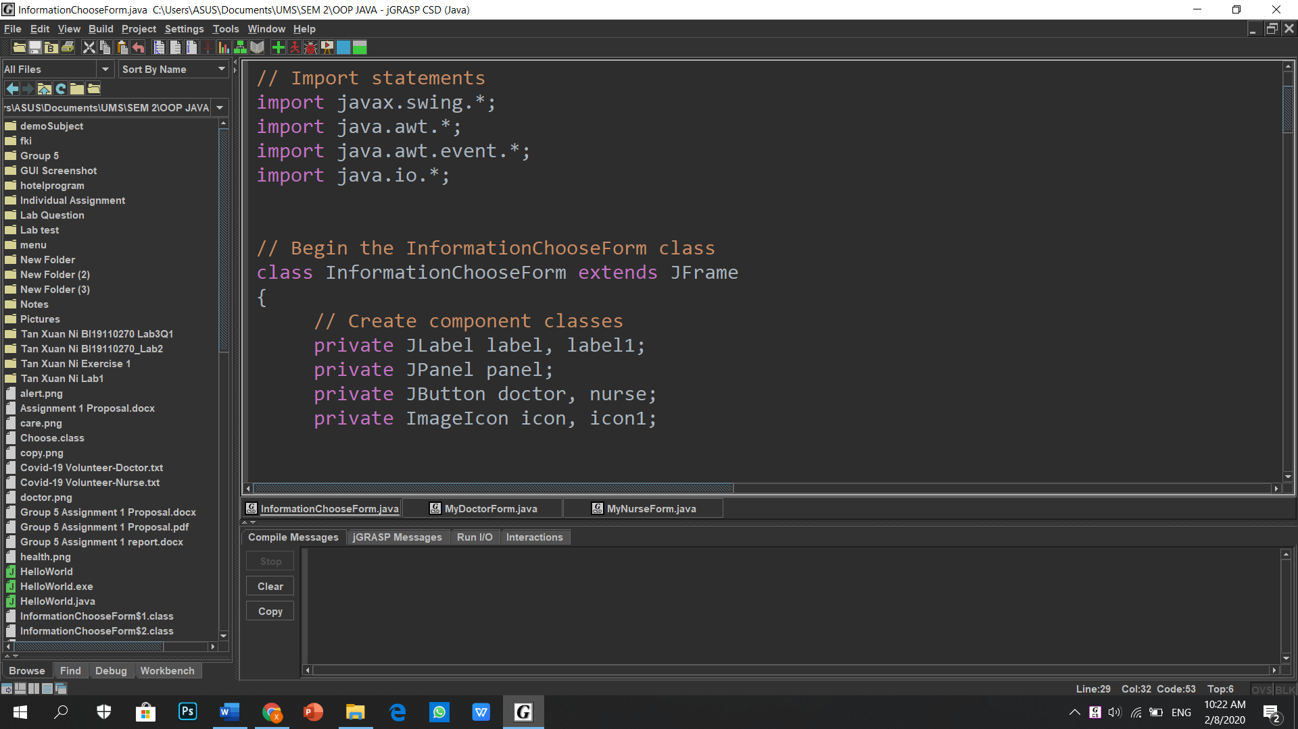

MyDoctorForm class inherits JFrame class.

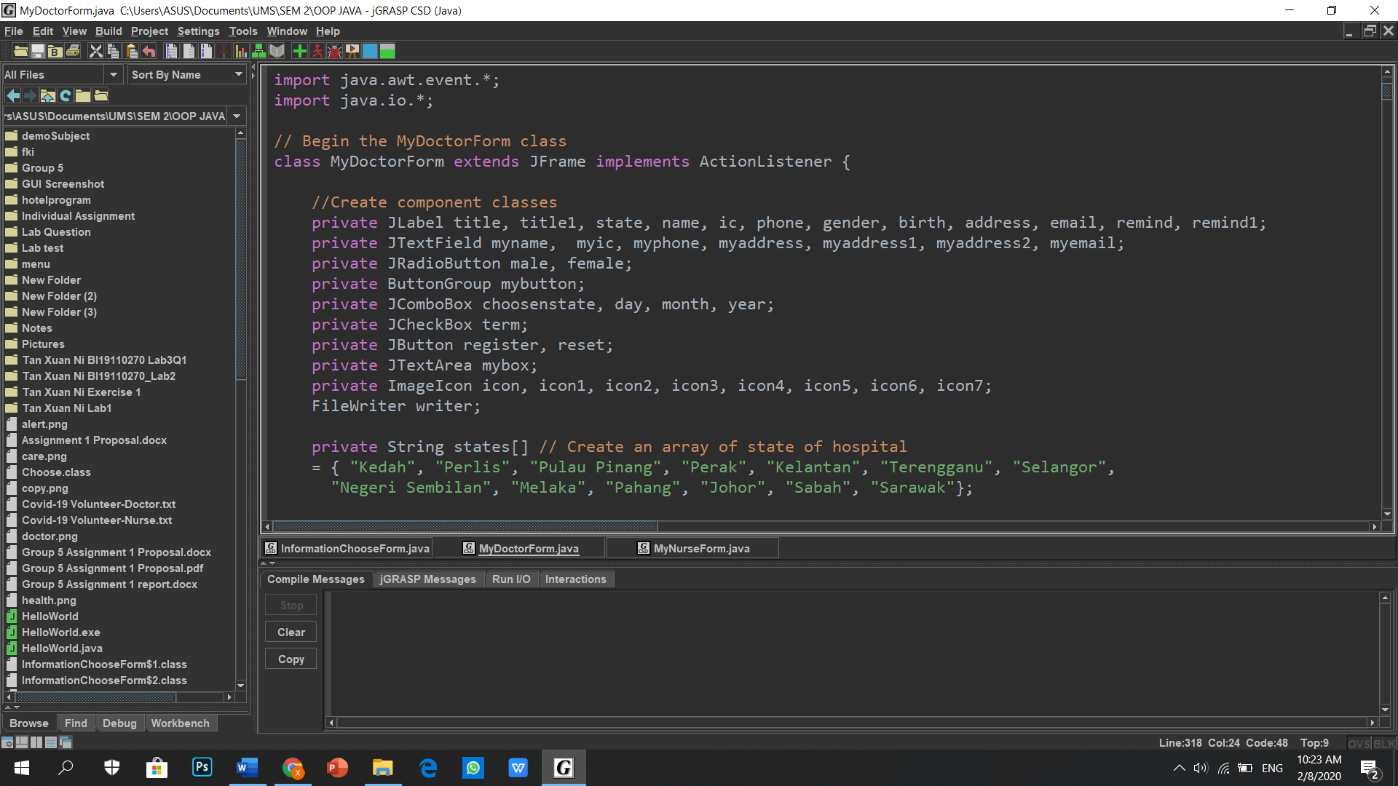

MyDoctorForm class inherits JFrame class.

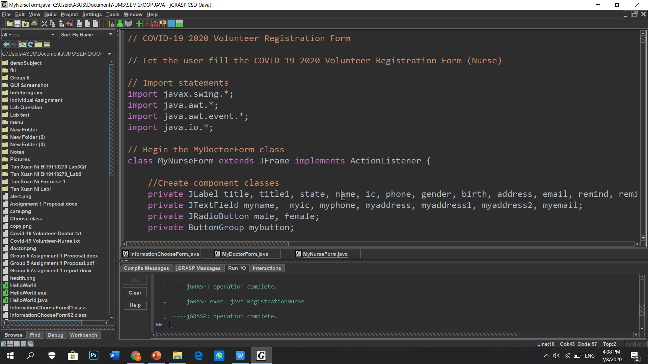

1. **Object and Classes:** A class called JFrame and an object called frame is created.

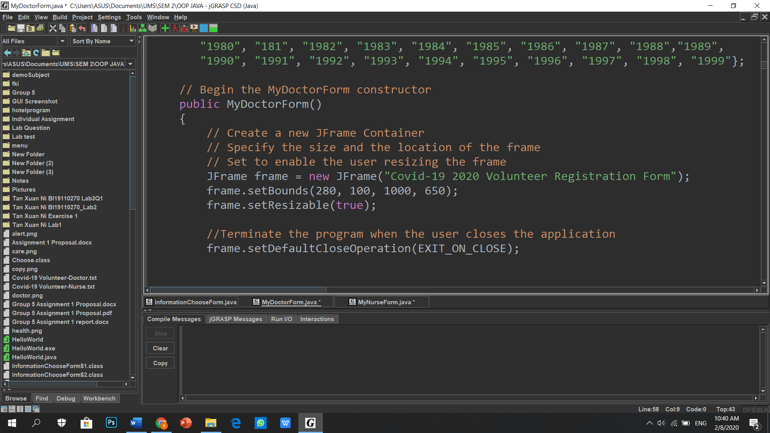

1. **Interface:** The JFrame class had implements the Action Listener interface.



1. **Inner Class:** Anonymous inner class is a class that have no name and it had used for implements the Action Listener interface.

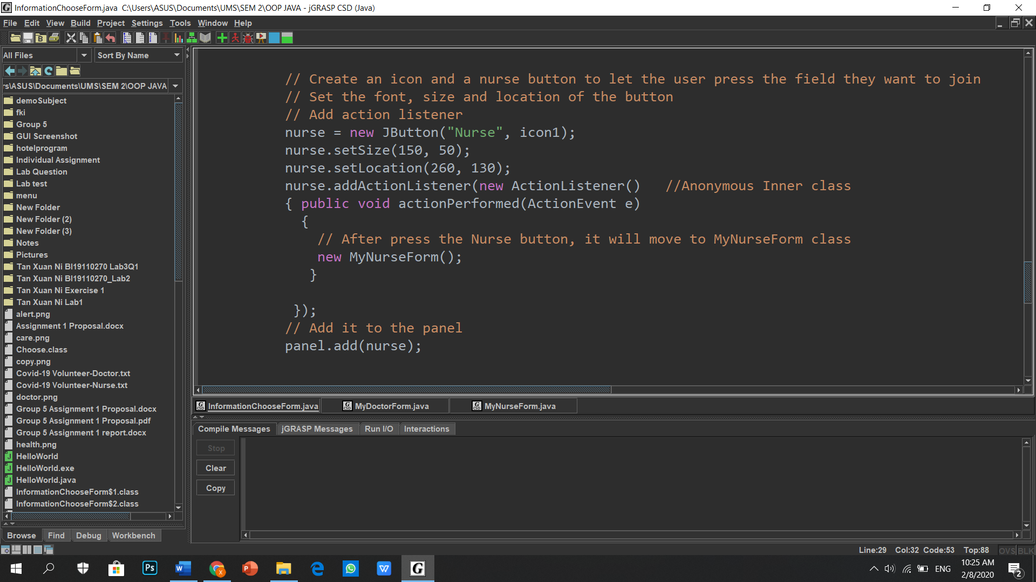

1. **Exception Handling:** Try and catch block had used for handle the exception.

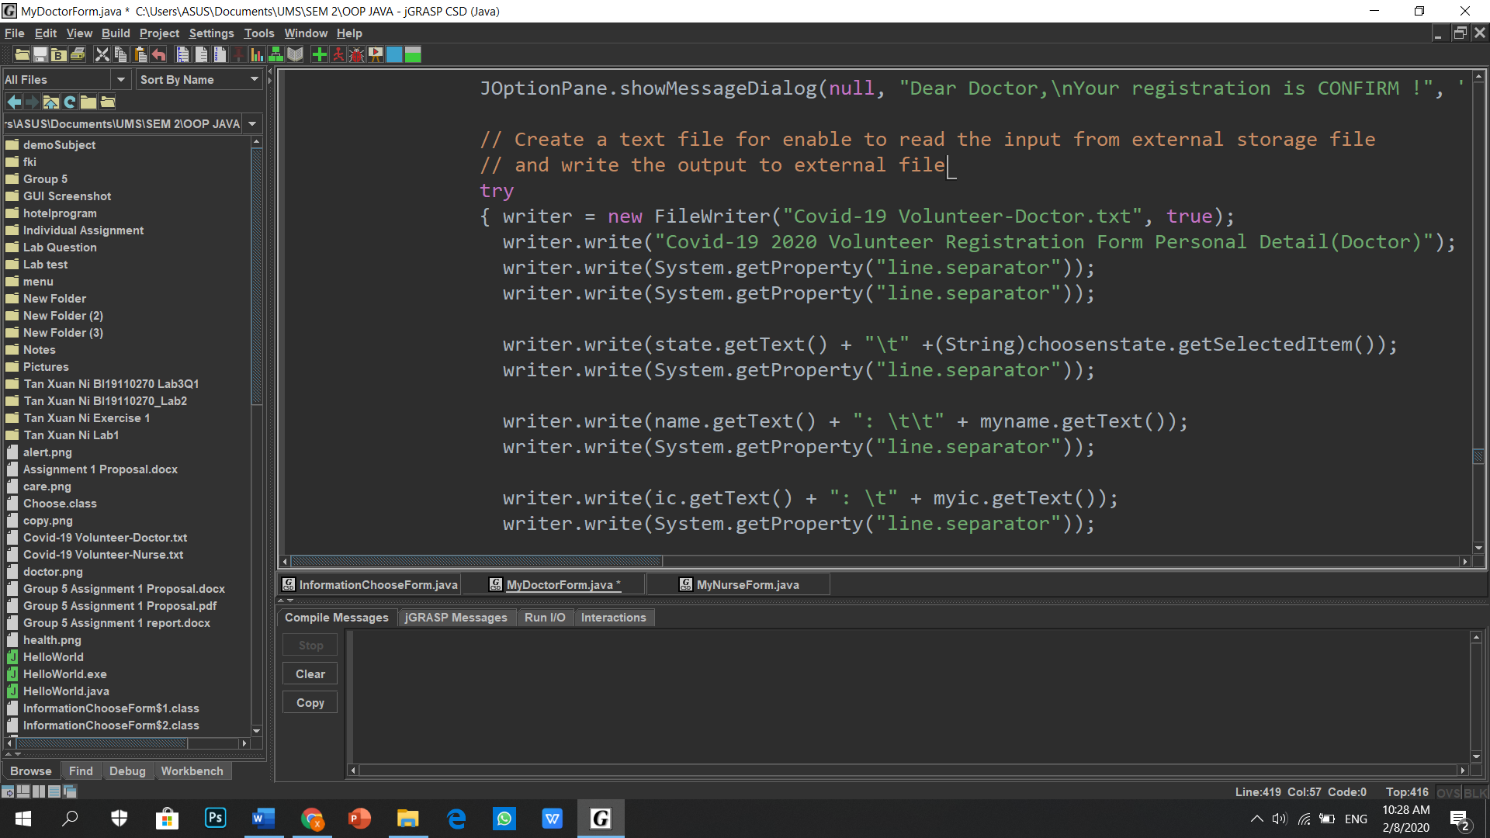

.  
.  
.

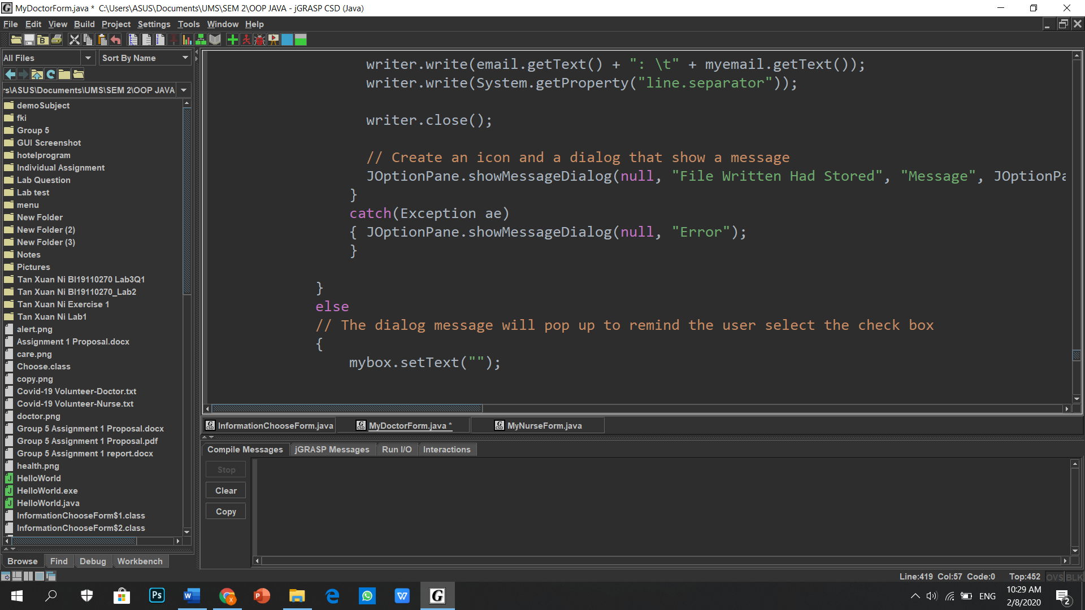

**6.0 Read and Write Implementation**

The user able to write the output to external file (.txt) and read the input from external storage file (.txt).

The two figures below show the personal details had written in MyDoctorForm class file and MyNurseForm class file.

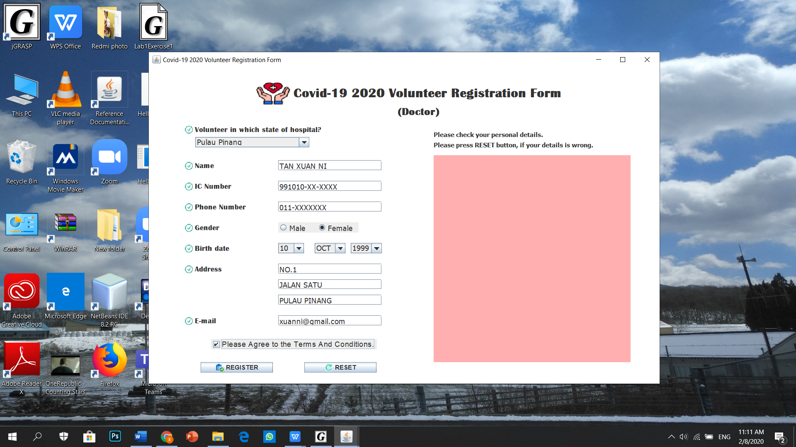

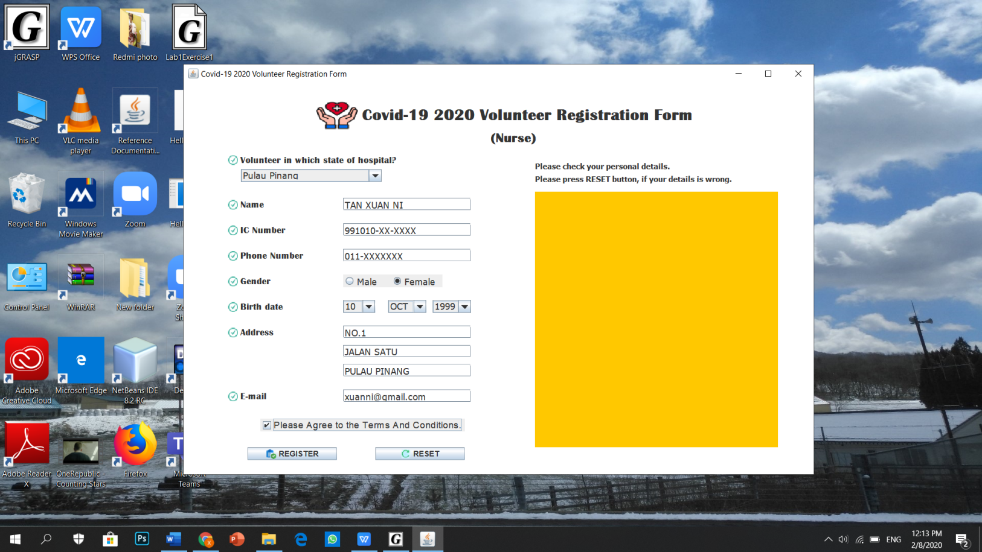

The two figures below show the personal details had stored into text file (.txt) from MyDoctorForm class file and MyNurseForm class file.

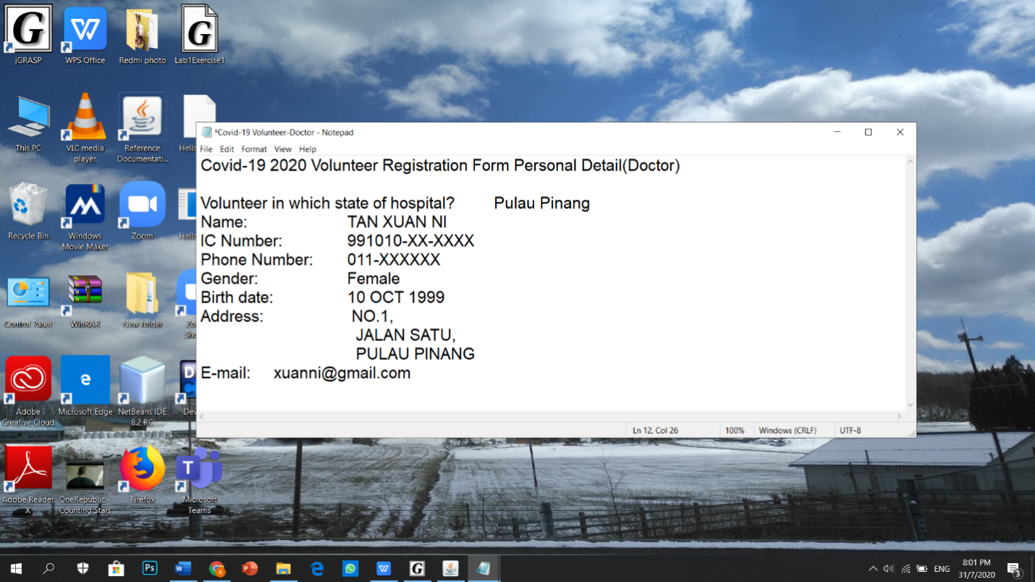

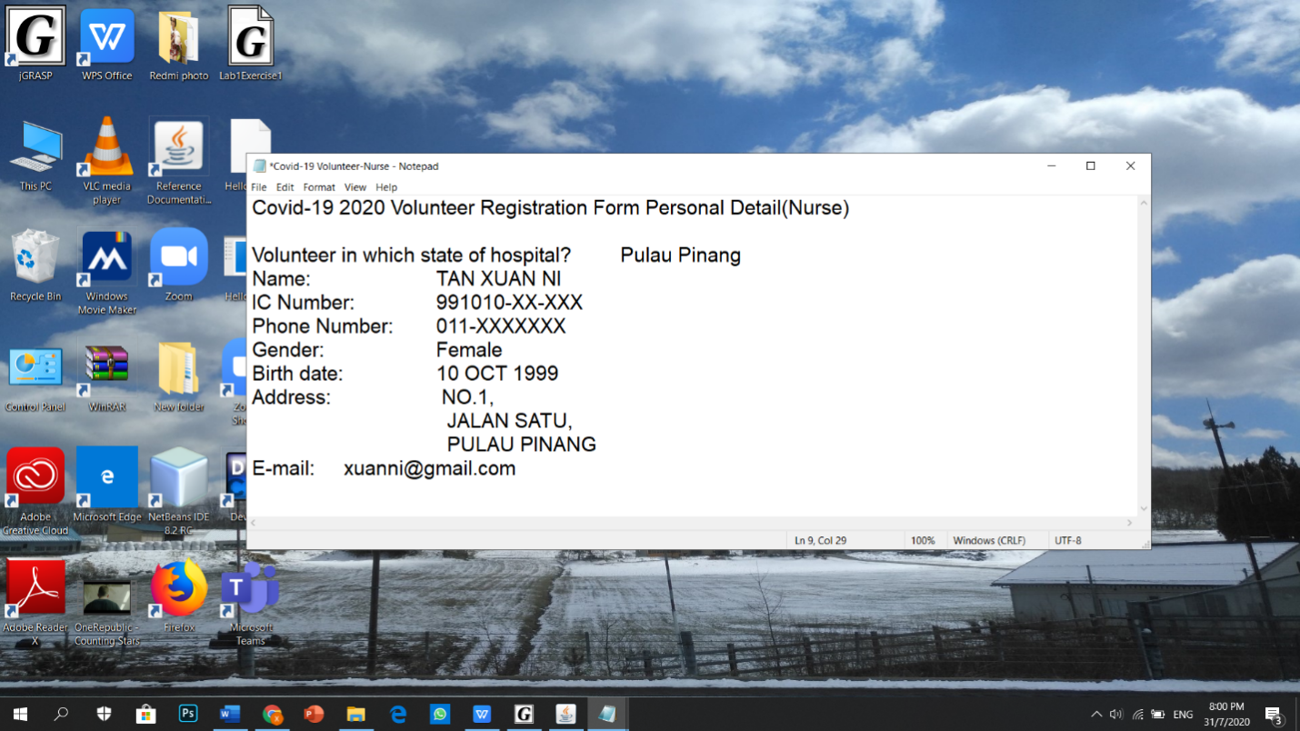

**7.0 User Manual (How to use the system)**

**Step 1:** Run the program.Press on the button that the field of volunteer (doctor or nurse) wanted to join by the user.

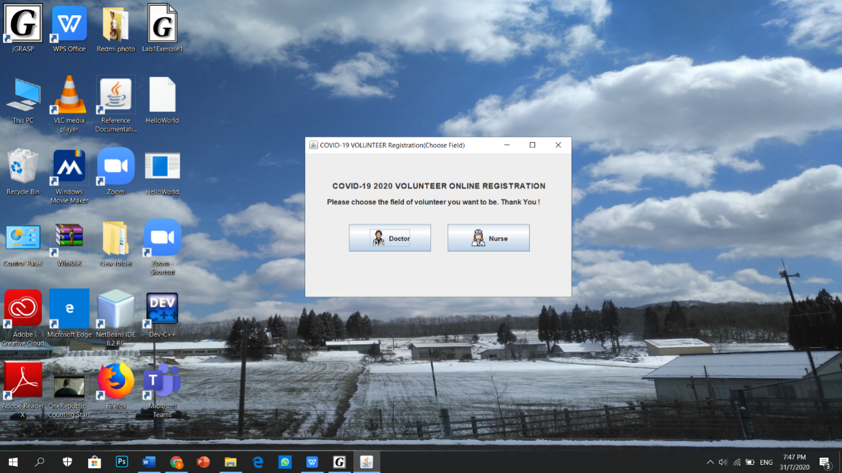

**Step 2:** If the user press “Doctor” button, it will switch to Doctor volunteer registration form.

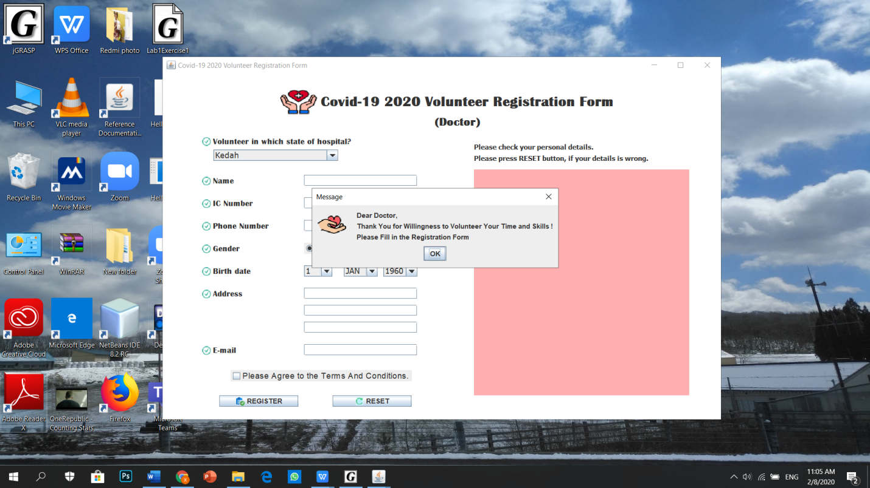

**Step 2 (a):** After press the “OK” button on the message dialog, fill in the details in the form given.



**Step 2 (b):** If the user finish filling the form and straight press “REGISTER” button, but they forget to select the check box (Terms and condition check box). The message dialog will call out to remind the user select the check box, then only can register.

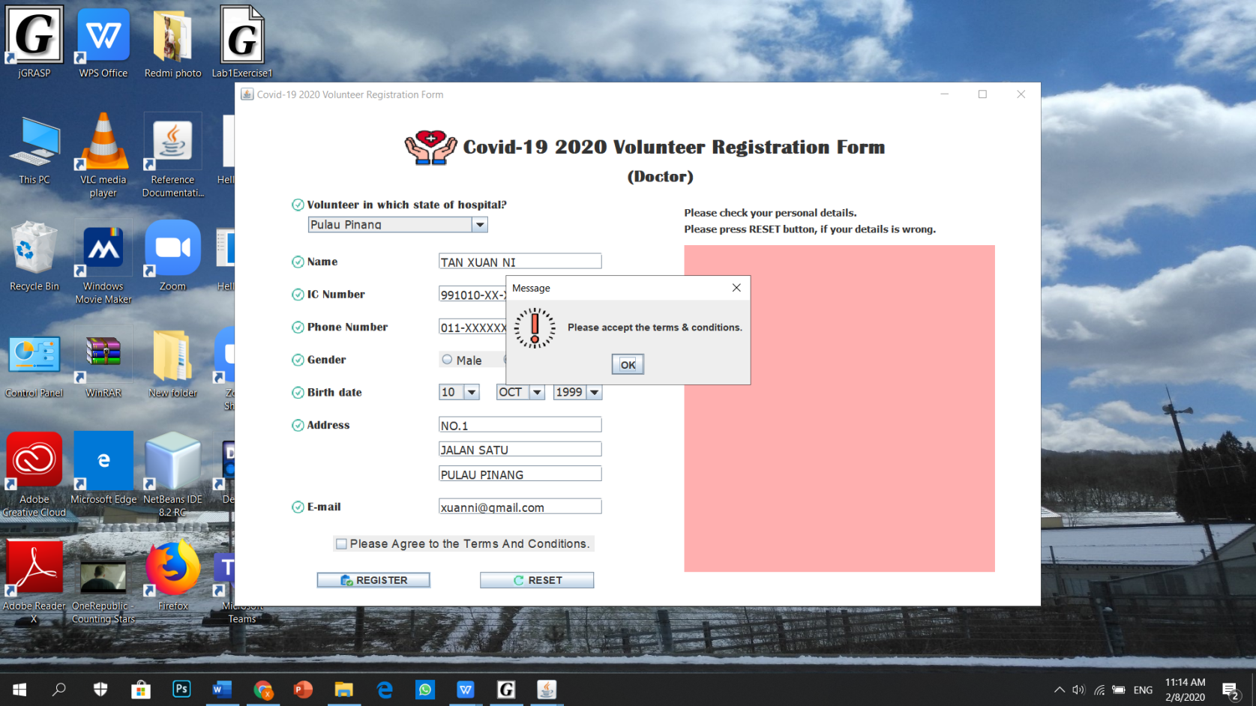

**Step 2 (c):** After finish fill in the form, press the “REGISTER” button, a message dialog will call out says the user had register. Then, the personal details will print out in the text area.

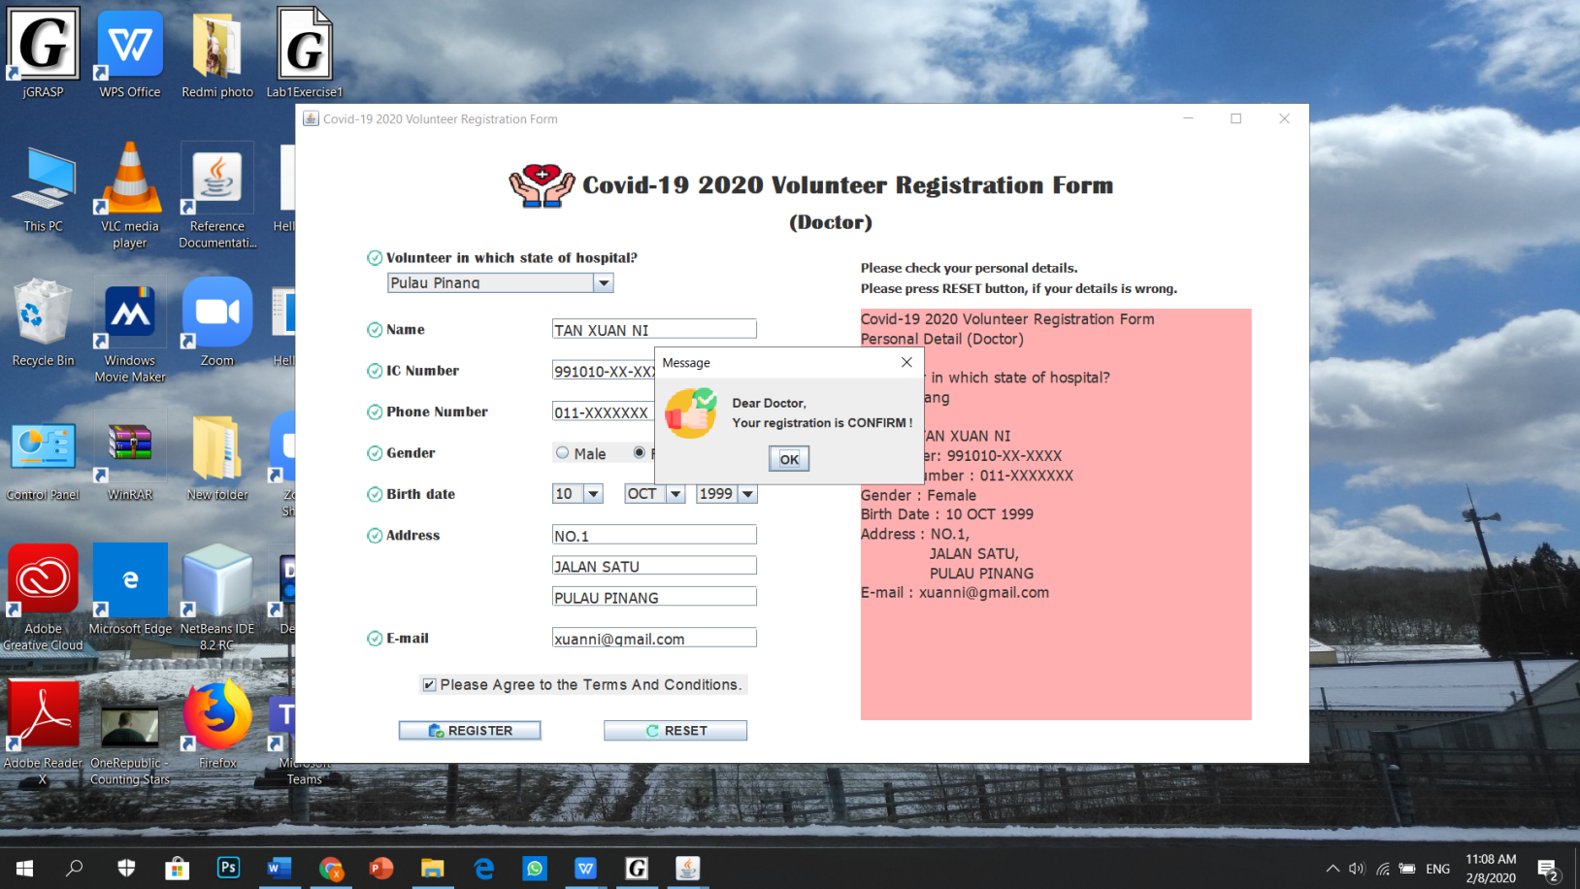

**Step 2 (d):** A message dialog also called out says that the personal details had store in external storage file which is text file (.txt). Next, the user can check the details written by them.

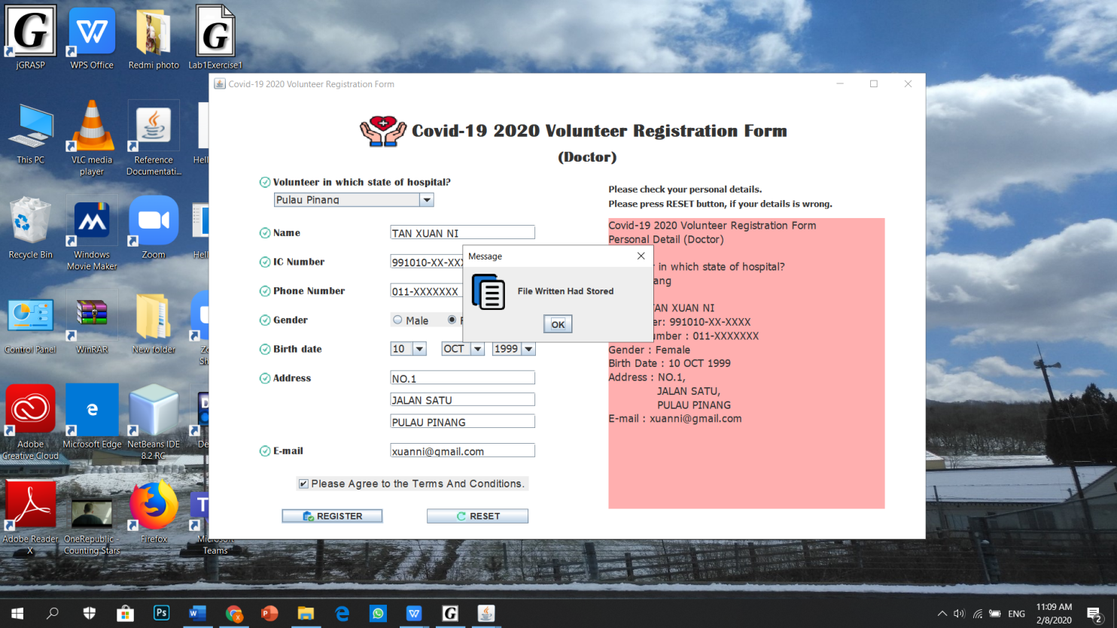

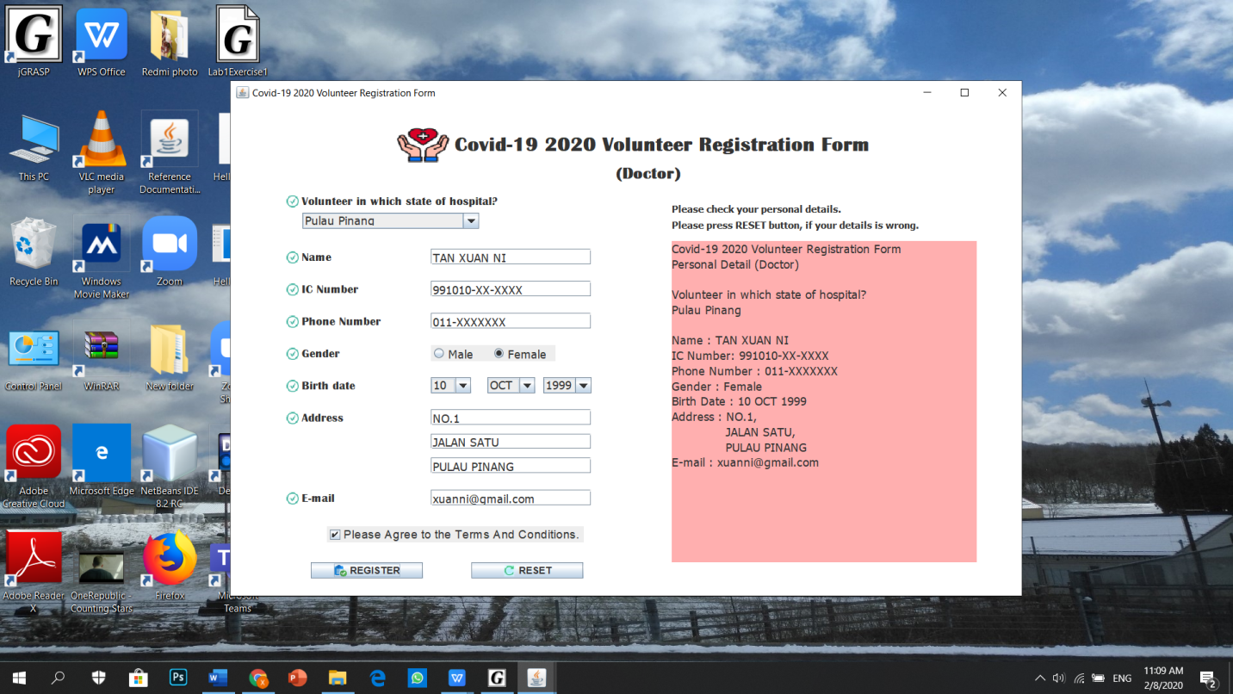

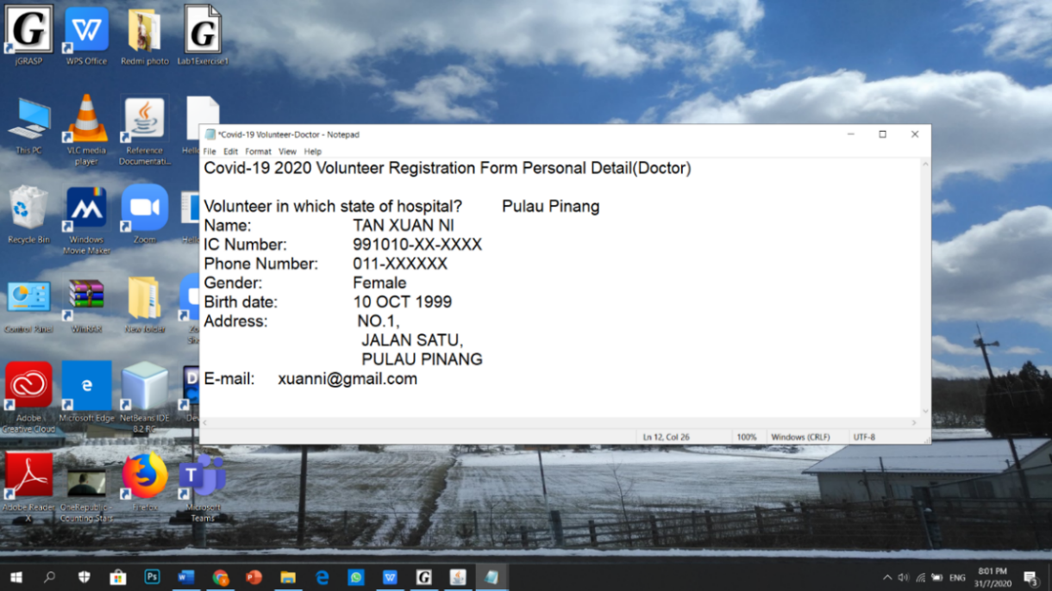

**Step 2 (e):** The user able to manipulate the personal details.If the user found that the details are wrong, they can press “RESET” button to clear all the details. The text field will be cleared and the user can fill in again.

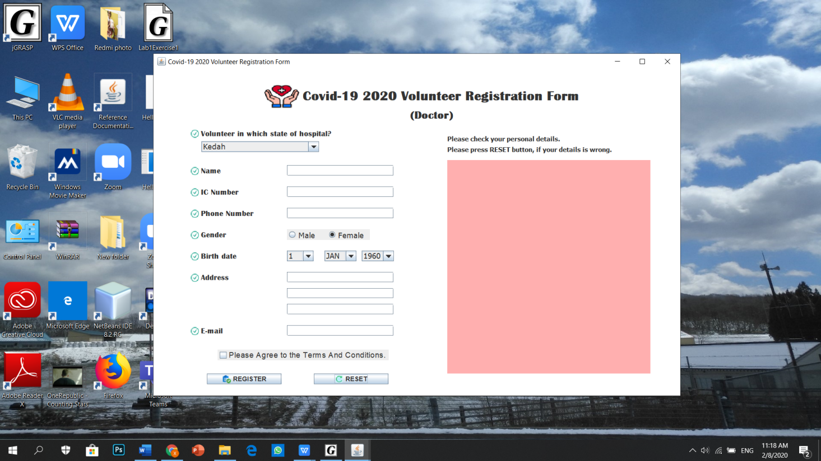

**Step 3:** Back to step 1, if the user press “Nurse” button, it will switch to Nurse volunteer registration form.

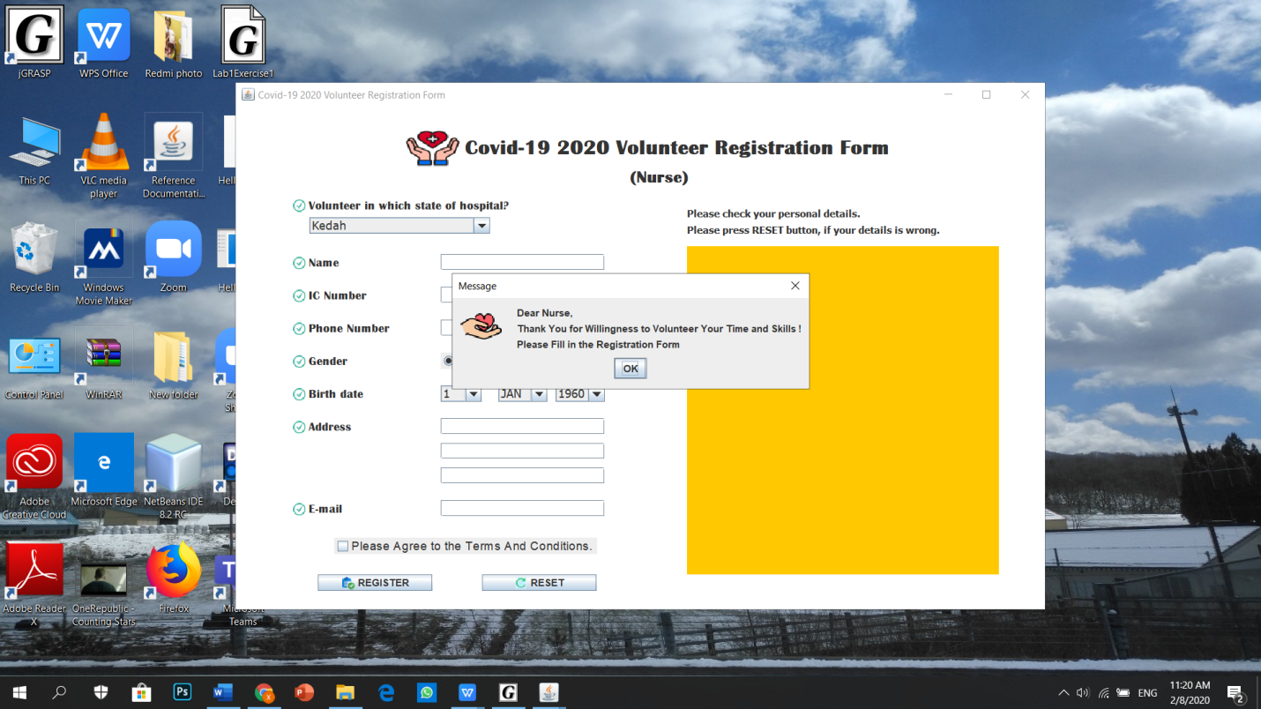

**Step 3(a) to step 3(e):** The following steps are same as step 2(a) to step 2(e).

The figure below shows the personal details from Nurse registration form had stored in the text file (txt.file).

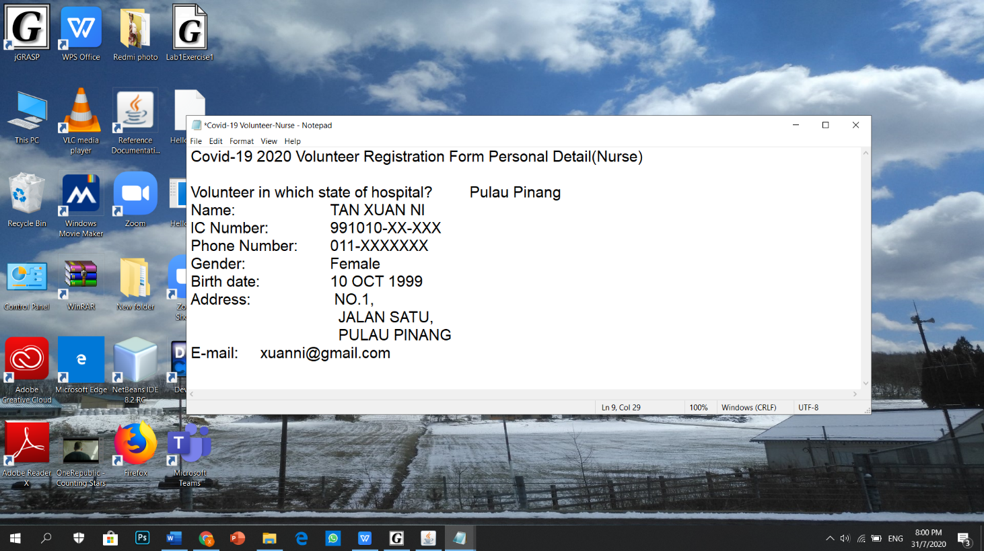

**Conclusion**

In conclusion, this online volunteer registration system has brought a lot of advantages to the admin and the volunteers because it can avoid the close contact with other people and reduce the transmission of coronavirus. It not only makes the management become easier and faster but it also saves a lot of money. The volunteer no need to worry about needing to make the registration at the counter within business hours because they can make their registration at any time and instantly. This system also helps to reduce the workload and time on admin. The admin can straight collect the information of the volunteers through this system and eliminates a lot of paperwork.

After finishing this assignment, I learned that we need to learn a lot of programming knowledge in Java to produce a GUI program. Then, I need to use those knowledge correctly to make sure the program can run smoothly.